REPORT : Huffman Encoding Algorithm & Data Compression
# 1.HUFFMAN - ENCODING ALGORITHM:

- Developed by David Huffman in 1951, this technique is the basis for all data compression and encoding schemes
- It is a famous algorithm used for lossless data encoding
- It follows a Greedy approach, since it deals with generating minimum length prefix-free binary codes
- It uses variable-length encoding scheme for assigning binary codes to characters depending on how frequently they occur in the given text. The character that occurs most frequently is assigned the smallest code and the one that occurs least frequently gets the largest code
#The major steps involved in Huffman coding are-
Step I - Building a Huffman tree using the input set of symbols and weight/ frequency for each symbol
- A Huffman tree, similar to a binary tree data structure, needs to be created having n leaf nodes and n-1 internal nodes
- Priority Queue is used for building the Huffman tree such that nodes with lowest frequency have the highest priority. A Min Heap data structure can be used to implement the functionality of a priority queue.
- Initially, all nodes are leaf nodes containing the character itself along with the weight/ frequency of that character
- Internal nodes, on the other hand, contain weight and links to two child nodes
Step II - Assigning the binary codes to each symbol by traversing Huffman tree
- Generally, bit ‘0’ represents the left child and bit ‘1’ represents the right child
#Algorithm for creating the Huffman Tree-
Step 1- Create a leaf node for each character and build a min heap using all the nodes (The frequency value is used to compare two nodes in min heap)
Step 2- Repeat Steps 3 to 5 while heap has more than one node
Step 3- Extract two nodes, say x and y, with minimum frequency from the heap
Step 4- Create a new internal node z with x as its left child and y as its right child. Also frequency(z)= frequency(x)+frequency(y)
Step 5- Add z to min heap
Step 6- Last node in the heap is the root of Huffman tree
#2.REAL WORLD APPLICATION as DATA COMPRESSION:--

- Huffman encoding is widely used in compression formats like GZIP, PKZIP (winzip) and BZIP2.
- Multimedia codecs like JPEG, PNG and MP3 uses Huffman encoding (to be more precised the prefix codes)
- Huffman encoding still dominates the compression industry since newer arithmetic and range coding schemes are avoided due to their patent issues.
- #2.1Why? :-
In the early 1980s, personal computers had hard disks that were no larger than 10MB; today, the
puniest of disks are still measured in hundreds of gigabytes. Even though hard drives are getting
bigger, the files we want to store (funny pictures of cats, videos, music and so on) seem to keep pace with that growth which makes even today's gargantuan disk seem too small to hold everything.
One technique to use our storage more optimally is to compress the files. By taking advantage of
redundancy or patterns, we may be able to "abbreviate" the contents in such a way to take up less space yet maintain the ability to reconstruct a full version of the original when needed. Such compression could be useful when trying to cram more things on a disk or to shorten the time needed to copy/send a file over a network.
There are compression algorithms that you may already have heard of. Some compression formats,
such as JPEG, MPEG, or MP3, are specifically designed to handle a particular type of data file. They are lossy—decompressing the compressed result doesn't recreate a perfect copy of the original. Such an algorithm compresses by "summarizing" the data. The summary retains the general structure while discarding the more minute details.
#An example of a lossy algorithm for compressing text would be to remove all the vowels. Compressing the previous sentence by this scheme results in:
n xmpl flssy lgrthm fr cmprssng txt wld b t rmv ll th vwls.
This shrinks the original 87 characters down to just 61 and requires only 70% of the original space.
For files containing text, we usually want a lossless scheme so that there is no ambiguity when re-
creating the original meaning and intent.

#2.2How?
#2.2.1.File compression
A text file is usually stored as bits in our system by converting each character to 8-bit
ASCII code. The ASCII encoding is called as fixed-length encoding, where each character
is converted to a fixed number (same number) of bits. If each character uses 8-bits, then
the total number of bits required is 8 times the number of characters. But the main idea is
to reduce the space the required to store the text file [Mackenzie, 1980]. Hence, we need
a compression function which results same output with less number of bits. This achieved
by variable-length encoding, which uses binary codes of different characters with different
lengths. If a character occurs more frequently, we represent it with fewer bits and more
number of bits to characters with low frequency.
1.Let us consider an example, say x is a text we want to encode.
∴ x = bala
Here, we have only three characters a, b, l for encoding. if we do a fixed-length en-coding, we need at least two bits for each character. Therefore, we need 8-bits to represent.
2.Suppose, if we decide to use the following bits for a, b, and l
a = 0, b = 11, l = 10
3.Then x is encoded as 110100. It takes only 6 bits which is less when compared to fixed-length encoding. The reason we choose these values for a, b, l is because of the ambiguity faced by variable length encoding while decoding the text. In any given case,we want to decode a text uniquely .

4.Suppose that, we want to decode 110100, we get our original text x as bala. Assume that, a = 0, b = 01, l = 00. Still the encoding text should result 6 bits only and the encoding text is 010000. Now, there is an ambiguity for decoding the encoded text. With 01 it could either be a or b. But it must be b, because we are using 01. The remaining zeros (0000) could be bala, bll or baaaa. Therefore, proper care should be taken while working with variable length coding.

5.To prevent the ambiguities while decoding, we need to make sure that encoding satisfies the prefix rule, that is, no code should be prefix of the other.
∴ a = 0, b = 11, l = 10 satisfies the prefix rule
The code or bits which satisfy this rule are represented using tree structure. The characters are stored at the external nodes, 0 is assigned to left child and 1 is assigned to right child

#2.2.2Optimal compression:
We need to ensure that the encoded text is short and requires less number of bits. For example, let us consider a text message:
x = malayalam
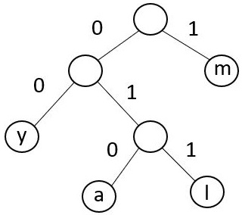

Figure 4.1: Encoded Tree structure
From Figure 4.1 and table 4.1, the total number of bits required is 22 and the text
malayalam is represented as following:
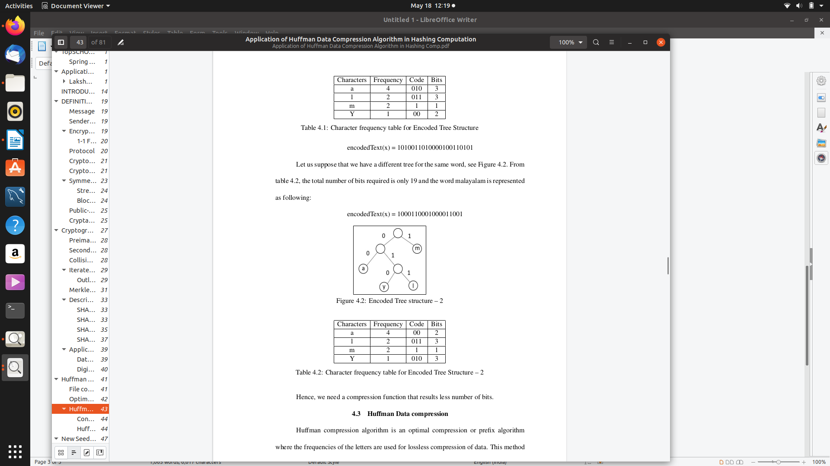

Let us suppose that we have a different tree for the same word, see Figure 4.2. From
table 4.2, the total number of bits required is only 19 and the word malayalam is represented
as following:
encodedText(x) = 1000110001000011001 Figure 4.2: Encoded Tree structure – 2

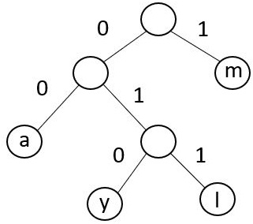
Hence, we need a compression function that results less number of bits.

#3.HUFFMAN COMPRESSION ALGORITHM:

Huffman compression algorithm is an optimal compression or prefix algorithm where the frequencies of the letters are used for lossless compression of data. This method uses a special technique for representing symbols for each word, resulting in bit strings representation

#3.1Construction of algorithm:
1.Suppose, for a given text, we need to count the frequency of characters and compute a tree so that the length of the encoding text is minimum, each character is a node in the tree. The root is always zero and level numbers are represented using number of bits to encode a character. If f is the frequency, then f k is the frequency of the k th character. Here, l is the level and l k is the level of the node of k th character. Therefore, we need to find a tree which minimizes ∑ k f k l k which is known as the total external weighted path length of a tree.

2.We consider each node having weight equal to the frequency of the characters. If
there are n number of weights, the frequencies are represented as f 1 , f 2 , f 3 , ..., f n . For these
frequencies, we can build a tree whose external weighted path length is minimum, it is
donated by WEPL( f 1 , f 2 , f 3 , ..., f n )

3.Huffman Tree:-Let us suppose that, an input x is to be compressed. Huffman algorithm calculates
the weights of the tuples in the input. Once this step is achieved, it begins to sum the least weights of the order at each level. Once the last node or symbol weight is calculated, it forms a tree and considers the sum of weights at each level as nodes.
This tree is assigned with a bit strings for presentation, left-side of the tree with 0s and right-side with 1s.
Ex:- x = mississippi
The frequencies of x are calculated as follows:
m = 1, p = 2, i = 4, s = 4 .Now, the least weights are calculated as follows:
m + p = (1+2) = 3, at level 1. See Figure 4.3.

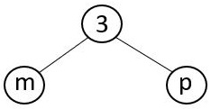

Figure 4.3: Huffman level 1
Again, it compares the weights with next character in queue and calculates the sum
as follows:(level 1 + i) = (3 + 4) = 7, at level 2
(level 2 + s) = (7 + 4) = 11, at level 3
Bit strings of 0s and 1s are assigned as follows:

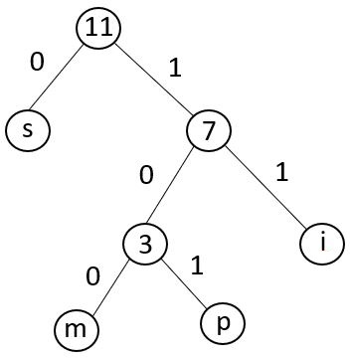

Figure 4.4: Huffman Tree
The number of bits required by the word mississippi is calculated from table 4.3.
The total number of bits required is 21.
∴ Huffman(mississippi) = 100110011001110110111
Using the fixed-variable length encoding scheme, the word mississippi requires 88 bits.
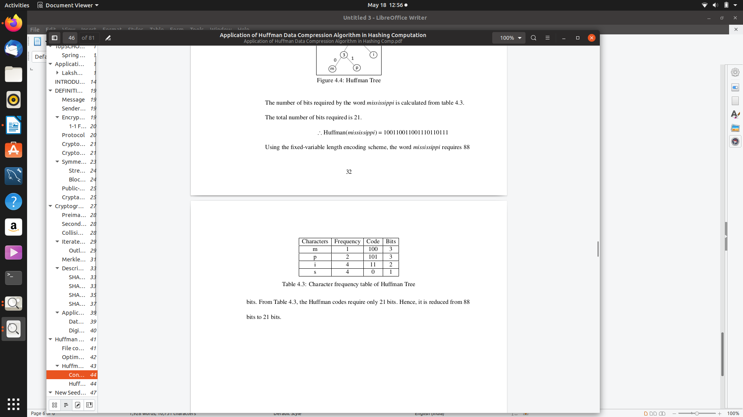

Table 4.3: Character frequency table of Huffman Tree
From Table 4.3, the Huffman codes require only 21 bits. Hence, it is reduced from 88
bits to 21 bits.

#4. ALGORITHM-ANALYSIS:-

Time Complexity Analysis-
Since Huffman coding uses min Heap data structure for implementing priority queue, the complexity is O(nlogn). This can be explained as follows-
- Building a min heap takes O(nlogn) time (Moving an element from root to leaf node requires O(logn) comparisons and this is done for n/2 elements, in the worst case).
- Building a min heap takes O(nlogn) time (Moving an element from root to leaf node requires O(logn) comparisons and this is done for n/2 elements, in the worst case).
Since building a min heap and sorting it are executed in sequence, the algorithmic complexity of entire process computes to O(nlogn) We can have a linear time algorithm as well, if the characters are already sorted according to their frequencies.

Advantages of Huffman Encoding-
- This encoding scheme results in saving lot of storage space, since the binary codes generated are variable in length
- It generates shorter binary codes for encoding symbols/characters that appear more frequently in the input string
- The binary codes generated are prefix-free

Demerits of Huffman Encoding-
- Lossless data encoding schemes, like Huffman encoding, achieve a lower compression ratio compared to lossy encoding techniques. Thus, lossless techniques like Huffman encoding are suitable only for encoding text and program files and are unsuitable for encoding digital images.
- Huffman encoding is a relatively slower process since it uses two passes- one for building the statistical model and another for encoding. Thus, the lossless techniques that use Huffman encoding are considerably slower than others.
- Since length of all the binary codes is different, it becomes difficult for the decoding software to detect whether the encoded data is corrupt. This can result in an incorrect decoding and subsequently, a wrong output.
#5.OPTIMIZATION OF ALGORITHM PERFORMANCE:-

#5.1. New Approach:- Optimized Huffman- compressed code by HASHED-HUFFMAN COMPRESSED CODE using SHA-1 Algorithm.

1.It is clearly visible that, most of the cryptanalytic attacks either theoretical or practical on followed chosen-prefix collision attack to break the compression algorithm. Attackers have followed Identical-prefix collision attack, that is, a prefix is extended with a pair of messages which has close calls to collide for any suffix. With SHA-1 calls the messages collided and resulted same hash value.

2.With the idea of chosen-prefix attack, we assumed that introducing the bit strings (0s and 1s) generated by Huffman hashed compression algorithm would be ideal and it will beharder for the attacker to break the algorithm.

#5.2 New Seed Construction:- In this section, we explain how the 512-bit message block for preprocessing stage is constructed. As mentioned , we used SHA-1 algorithm.

1.For constructing a message block y in SHA-1 , the length is 512-bits or multiples of 512 and we pad the original message with 1 extra bit, 447 0s and length of the original message (64 bits).

y = message || 1 || 0 447 || 64

2.In our new seed construction, we removed 1 extra bit and replaced 447 0s with 288 0s and 160-bit message digest of the Huffman codes.

y seed = message || SHA-1(Huffman) || 0 288 || 64

If we observe y seed , the total length of the message block is 512 bits or multiples of 512 bits.

3.Steps involved in construction:-

• For any given message x, we calculate the frequencies of the characters and gen-
erate the Huffman compressed codes, see table 5.1 and Figure 5.1

x = abracadabra

Huffman(x) = 0 110 111 0 100 0 101 0 110 111 0
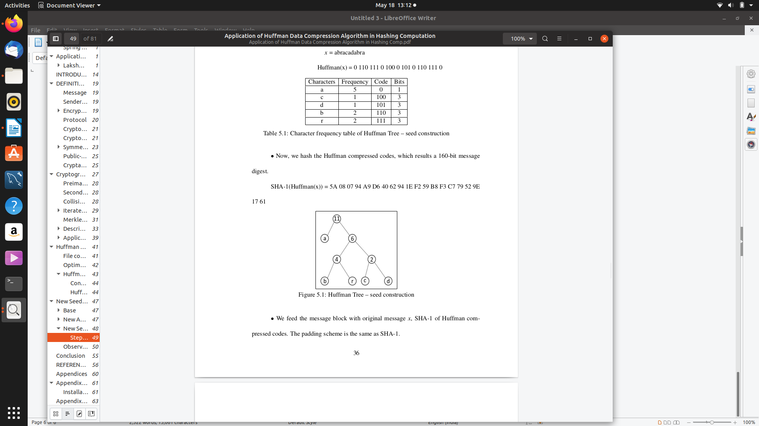

• Now, we hash the Huffman compressed codes, which results a 160-bit message digest.We feed the message block with original message x, SHA-1 of Huffman compressed codes.

SHA-1(Huffman(x)) = 5A 08 07 94 A9 D6 40 62 94 1E F2 59 B8 F3 C7 79 52 9E 17 61

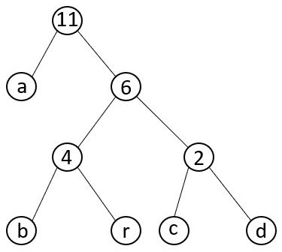

Figure 5.1: Huffman Tree – seed construction

4.Observations & Figure 5.2: Compression function output:-

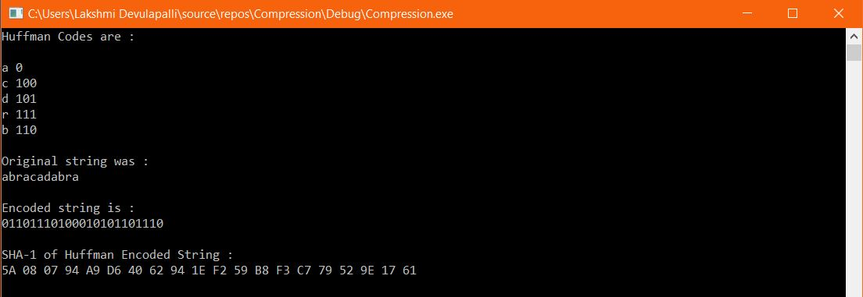
#6.CONCLUSION & MERITS :

There are always chances for cryptanalytic attacks due to over growing technological revolution and can compromise the security of the systems. The optimized vision of this report aims to design a hash algorithm by adding an extra layer, that is, by adding the hash value of Huffman compressed codes of the original message to the preprocessing stage of SHA-1. We tested our algorithm for different bruteforce words and sample messages which broke SHA-1. The results show that, any message with same original SHA-1 message digest and messages with same Huffman compressed codes did not collide and resulted different message digests. SHA-1 algorithm depends on the length of the original message, whereas, Our algorithm depends the frequency of the characters of original message as well as the length of the original message. Hence, at this point of time we conclude that our algorithm is collision resistant.
By- LIT2018030 (Sheetal Rani)

